Solution for Paper 1

1 | C | 11 | C | 21 | C | 31 | A
 | A |  | C |  | B |  | B
 | A |  | C |  | B |  | D
 | D |  | B |  | D |  | C
 | A |  | D |  | D |  | D
6 | D | 16 | D | 26 | C | 36 | D
 | C |  | C |  | A |  | A
 | B |  | D |  | A |  | B
 | B |  | B |  | D |  | A
 | A |  | B |  | A |  | B
Solutions for 2010 NJC H2 Preliminary Examination Paper 3

δ+ δ−

1 (a) (i) K⁺ [F: H - F]⁻
H-bond

1 (a) (ii) - CO₂ is a linear non-polar discrete molecule; hence only weak Van der Waals (VDW) forces exist between them. The kinetic energy possessed by CO₂ molecules at room temperature and pressure is sufficient to overcome these interactions, so the molecules are far apart and exist in the gaseous phase.
H₂O is a discrete molecule capable of having H-bonding between the molecules. These are much stronger than the weak VDW forces. The KE of the H₂O molecules under room conditions is not enough to overcome all the H-bonding interactions, thus resulting in them existing in small clusters as a liquid phase.

1 (b) (i) 2K(s) + C(s) + 1½ O₂(g) → K₂CO₃(s) ΔH_{formation}

1 (b) (ii) ΔH_{soln} = -1254/0.0362 x 10⁻³ = -34.7 kJ mol⁻¹

1 (b) (iii)
ΔH_{f} = -1146.3 kJ mol⁻¹

1 (c) (i) 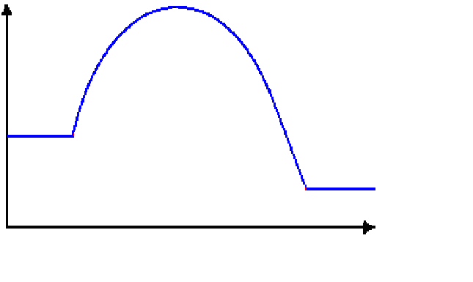
Energy/ kJmol ⁻¹
Reaction pathway
products
reactants
E_{a} = 25 kJmol ^{‒1}
ΔH = ‒ 41 kJmol ^{‒1}

1 (c) (ii) Fe₃O₄ functions as a heterogeneous catalyst. The reactant molecules are adsorbed onto the surface area of Fe₃O₄. This weakens the existing bonds in the reactant molecules. Thus, Fe₃O₄ lowers the activation energy of the reaction, allowing rate of reaction to increase.

1 (c) (iii) When a catalyst provides an alternative pathway with a lower activation energy for the reaction to take place, there is a larger proportion of molecules with energy greater than activation energy. Thus rate of reaction increases.

Fraction of molecules
Energy
E_{a} for uncatalysed reaction
E_{a} for catalysed reaction

1 (c) (iv)
Kp = 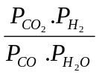
= 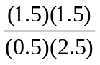
= 1.8

1 (c) (v) When aqueous sodium hydroxide is added, CO₂ is removed. Thus by Le Chatelier’s Principle, position of equilibrium shifts right to produce more CO₂.

2 (a) (i) ketone, alkene, secondary alcohol.

2 (a) (ii)
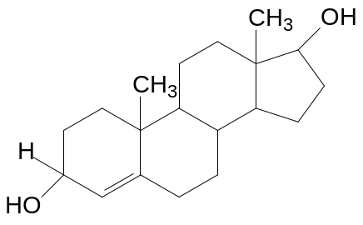

2 (a) (iii) No. The double bond is found in the ring; hence the ring cannot be twisted to get the other isomer.

2 (b) (i) Brick red (reddish brown) precipitate.

2 (b) (ii) I₂; NaOH; warm
Progesterone gives a yellow ppt.

2 (c) (i) B = Mg(OH)₂

D = CuCl₄²⁻

2 (c) (ii) Aqueous Cu²⁺ has 5 degenerate d-orbitals.
H₂O ligands approach Cu²⁺ along the axis and split it up into 2 different energy levels..
Since Cu²⁺ have partially filled d-orbitals, electrons in the lower energy d-orbital will absorb light of a certain wavelength and get promoted to a higher energy d-orbital.
Blue colour is complementary of the wavelength absorbed.

2 (c) (iii) In A the ligands present is H₂O; In C the ligands present is NH₃
Different ligands split the d-orbitals to different extent, i.e. ΔE is different. Hence different wavelength is absorbed and therefore different colour is seen.

2 (d) (i) Mg²⁺ has a higher charge over ionic radius ratio than Cu²⁺
ΔH_{hydration} of Mg²⁺ is more exo than ΔH_{hydration} of Cu²⁺
L.E is approximately constant in both compounds
ΔH_{solution} of Mg(OH)₂ is more exo than ΔH_{solution} of Cu(OH)₂

Hence Mg(OH)₂ is more soluble than Cu(OH)₂.

2 (d) (ii) 7.2 × 10⁻²⁰ mol dm⁻²

2 (d) (iii) Higher due to the absence of common ion effect.

3 (a) (i) The pH value of 2.2 represents the maximum buffer capacity.

3 (a) (ii) pH = 1.65

3 (a) (iii) NaH₂PO₄.

3 (b) (i) H₂PO₄⁻ + OH⁻ → HPO₄⁻ + H₂O

3 (b) (ii) Mass of NaOH = 0.366 grams

3 (c) The NH₃ gas that is formed dissolves in the water present in soil to give OH⁻ ions, thus increasing the soil pH temporarily.
Over time, the NH₃ gas escapes and NH₄H₂PO₄ dissociates to give NH₄⁺ and H₂PO₄⁻, which will hydrolyse in water to give H₃O⁺, therefore the soil becomes more acidic than before.

3 (d) (i) Anode: C₂H₅OH + 3H₂O → 2CO₂ + 12H⁺ + 12e⁻
Cathode: 4H⁺ + O₂ + 4e⁻ → 2H₂O

Overall: C₂H₅OH + 3O₂ → 2CO₂ + 3H₂O

3 (d) (ii) Phosphoric acid can act as a charge carrier.

3 (d) (iii) Carbon paper is porous. Platinum acts as catalyst for oxidation of ethanol.

3 (d) (iv) High costs involved in maintaining the high temperature.
High costs involved as platinum catalyst is expensive.

3 (e) Q at 75% efficiency = 759 kJ

4 (a) (i) P is less electronegative than Cl, hence H₂O attacks the partial positively charged P and displace Cl to form H₃PO₃ and HCl.

PCl₃ + 3H₂O → H₃PO₃ + 3HCl

N is more electronegative than Cl, hence H₂O attacks the partial positively charged Cl to form HOCl and NH₃.

NCl₃ + 3H₂O → 3HOCl + NH₃

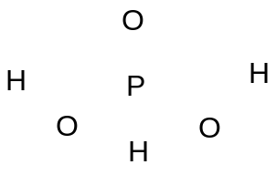
4 (a) (ii)

4 (b) (i) Thermal stability of hydrogen halide (HX) decreases down the Group. As size of the halogen atom increases down the Group, degree of orbital overlapping between the H and halogen atom decreases. Therefore, strength of H-X bond decreases and hence, less heat energy is required to break the H-X bond. This is evidenced from that fact that HCl shows little tendency to decompose to strong heating. HBr can be decomposed on strong heating, while HI will decompose and produce copious violet fumes of iodine vapour by introducing a red hot needle into a jar of HI.

4 (b) (ii) 2 ICl₃ + 3H₂O → ICl
4 (c) (i) Only a few Cl∙ radicals are required to initiate/kick-start the propagation reaction, hence short duration of radiation will be sufficient.

4 (c) (ii)

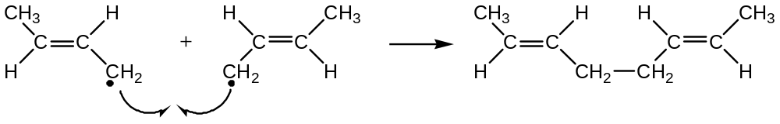

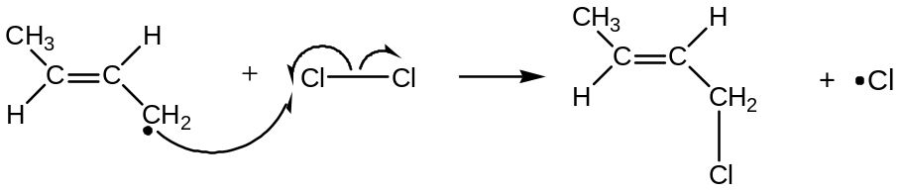
When 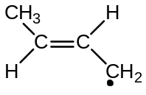 radical reacts with Cl₂, 1-chlorobut-2-ene is formed.

4 (d) 1-chlorobut-2-ene undergoes nucleophilic substitution/hydrolysis with NaOH(aq) to form AgCl white ppt.
2-chlorobut-2-ene does not undergo nucleophilc substitution. The C-Cl bond is harder to break due to overlap of Cl p orbital with the adjacent C=C bond. Hence no free Cl⁻ ions is formed to react with Ag⁺ to form AgCl white ppt.

4 (e)

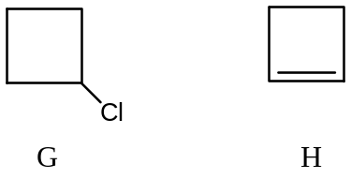

5 (a) (i) Electrophilic Substitution
Mechanism
- Generation of electrophile

+
+

5 (a) (ii) Add aqueous NaOH to a separating funnel containing the mixture of phenol and propanone. Shake thoroughly and drain off the aqueous layer. Acidify the aqueous layer with dilute HCl to recover the phenol.

5 (b) (i) & (ii)
Step | Reagents & Conditions | Product
1 | NaCN + dil HCl(to generate HCN)  trace amt of base | 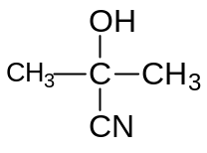
2 | dil H₂SO₄  reflux | 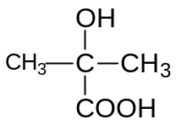
4 | CH₃OH, conc H₂SO₄  Reflux

5 (c) (i) Iodine – oxidizing agent
H₂SO₄ – catalyst

5 (c) (ii) NaHCO₃ – quench reaction by reacting with the catalyst, H₂SO₄:
conc of iodine present at diff time intervals can then be found.

NaOH – cannot be used as it can react with iodine producing sodium iodide and sodium iodate.

5 (c) (iii) Zero order wrt iodine
First order wrt sulphuric acid
(support answers with relevant explanation or working)

5 (c) (iv) Extrapolate curve to y-axis to find volume of thiosulfate required to react with the iodine present initially or at t = 0 min in a 10.0 cm³ reaction mixture.
Vol of thiosulfate reqd = 20.0 cm³
Use the equation I₂ + 2S₂O₃²⁻ → 2I⁻ + S₄O₆²⁻ to find amount of thiosulfate required to react with iodine present in 10.0 cm³ reaction mixture and hence conc of thiosulfate used. Conc. of thiosulfate used = 1.00 x 10⁻⁴ mol dm⁻³

5 (c) (v) Overall order of reaction is 2.
Since reaction is 1st order wrt sulphuric acid, zero order wrt iodine, hence it is 1st order wrt propanone

